## Reports/ Third Party Report/ Third Party Sales Analysis:

Request:

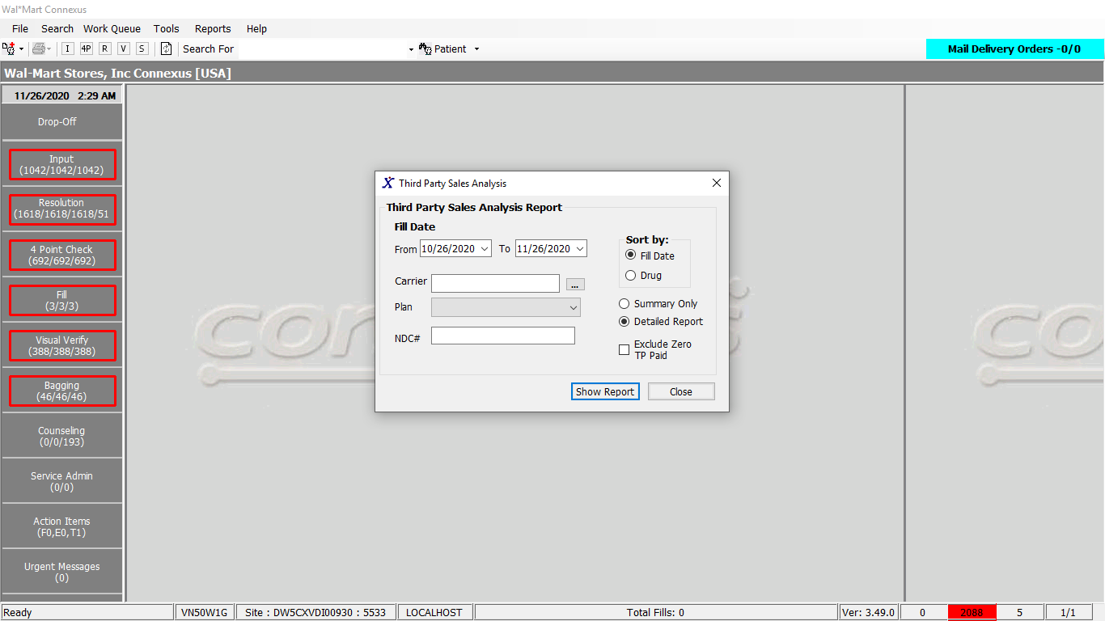

Response:

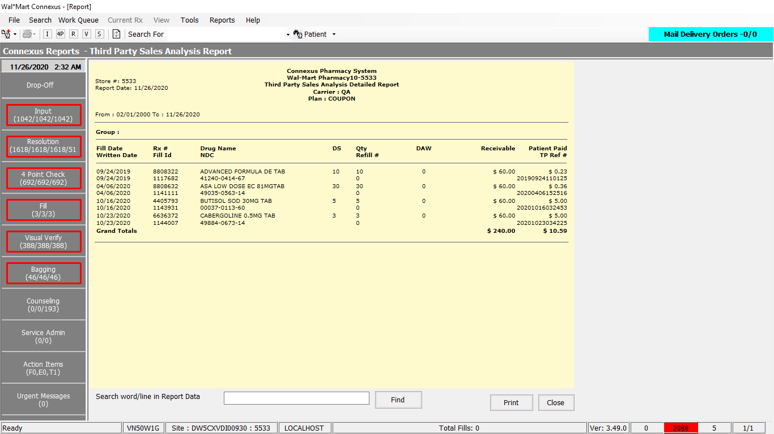

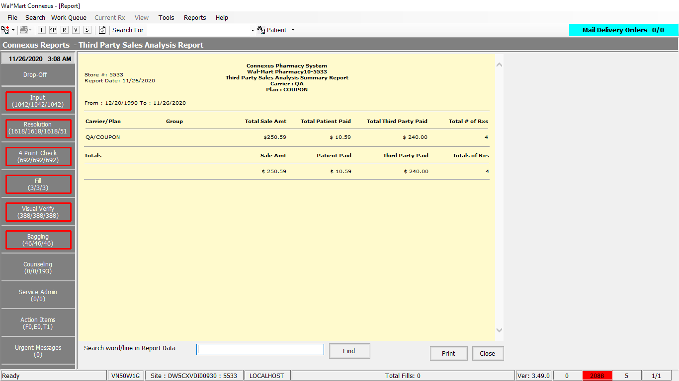

Query:

1. Public Const GetCountryCode As String = "SELECT country_code FROM bus_unit_addr WHERE bu_nbr = ?"

2. Friend Const GetThirdPartySalesAnalysisReportDataPart1 As String =

"SELECT rsd.aff_party_id , phm_co_name_abbr, rsd.ins_carr_plan_id, icp.ins_plan_ref_code, " &

"cs51.tp_group_id,SUM(rf.pos_sale_amt) total_sale_amt, SUM(rsd.txn_amt) total_tp_amt, SUM(( " &

"SELECT NVL(pos_patient_amt,0) FROM pos_activity pa " &

"WHERE pa.rx_fill_id = rf.rx_fill_id " &

"AND pos_txn_type_code = 5700 " &

"AND pos_seq_nbr = (SELECT MAX(pos_seq_nbr) " &

"FROM pos_activity pa1 " &

"WHERE pa1.rx_fill_id = pa.rx_fill_id " &

"AND pa1.pos_txn_type_code = 5700))) total_pat_amt, COUNT(rsd.rx_fill_id) totalrx " &

"FROM rx rx,rx_fill rf,rx_sale_detail rsd,ins_carrier_plan icp, claim_submn cs51,phm_company phmc " &

"WHERE rx.rx_id = rf.rx_id " &

"AND rsd.rx_fill_id = rf.rx_fill_id " &

"AND rf.third_party_ind = 'Y' " &

"AND rf.pos_ts IS NOT NULL " &

"AND rf.pos_sale_amt IS NOT NULL "

3.Friend Const GetThirdPartySalesAnalysisReportDataPart1D0 As String =

"SELECT rsd.aff_party_id , phm_co_name_abbr, rsd.ins_carr_plan_id, " &

"ins.ins_plan_ref_code,'' tp_group_id,SUM(rf.pos_sale_amt) total_sale_amt, " &

"SUM(rsd.txn_amt) total_tp_amt,SUM((SELECT NVL(pos_patient_amt,0)FROM pos_activity pa " &

"WHERE pa.rx_fill_id = rf.rx_fill_id " &

"AND pos_txn_type_code = 5700 " &

"AND pos_seq_nbr = (SELECT MAX(pos_seq_nbr) " &

"FROM pos_activity pa1 " &

"WHERE pa1.rx_fill_id = pa.rx_fill_id " &

"AND pa1.pos_txn_type_code = 5700))) total_pat_amt, " &

"COUNT(rsd.rx_fill_id) totalrx " &

"FROM rx rx,rx_fill rf,rx_sale_detail rsd,ins_carrier_plan ins,insurance_card ic , " &

"ins_card_particpnt ins1, phm_company phmc ,claim_response cr," &

"OUTER plan_billing_group pl ,OUTER plan_billing_group pl1 " &

"WHERE rx.rx_id = rf.rx_id " &

"AND rsd.rx_fill_id = rf.rx_fill_id " &

"AND rf.third_party_ind = 'Y' " &

"AND rf.pos_ts IS NOT NULL " &

"AND rf.pos_sale_amt IS NOT NULL "

4. Friend Const GetThirdPartySalesAnalysisReportDataPart2 As String =

"AND rf.status_code = 20401 AND rsd.status_code IN (21005, 21010) " &

"AND phmc.phm_co_id = rsd.aff_party_id " &

"AND rsd.aff_party_id = icp.carrier_co_id " &

"AND rsd.ins_carr_plan_id = icp.ins_carr_plan_id " &

"AND cs51.claim_submn_id = (SELECT MAX(cst51.claim_submn_id) " &

"FROM claim_submn_trnsm cst51,claim_resp cr51, claim_resp_trnsm crt51 " &

"WHERE cst51.claim_submn_id = cr51.claim_submn_id " &

"AND cst51.rx_fill_id = rf.rx_fill_id " &

"AND crt51.claim_resp_id = cr51.claim_resp_id " &

"AND crt51.resp_stat_code IN ('P','D','C')) " &

"AND rf.fill_date >= ? AND rf.fill_date <= ? "

5.Friend Const GetThirdPartySalesAnalysisReportDataPart2D0 As String =

"AND rf.status_code = 20401 " &

"AND rsd.status_code IN (21005, 21010) " &

"AND phmc.phm_co_id = rsd.aff_party_id " &

"AND rsd.aff_party_id = ins.carrier_co_id " &

"AND ins1.carrier_co_id = rsd.aff_party_id " &

"AND ins1.ins_carr_plan_id = rsd.ins_carr_plan_id " &

"AND ins1.cardholder_id = rsd.aff_prty_ref_id " &

"AND ic.carrier_co_id = ins1.carrier_co_id " &

"AND ic.ins_carr_plan_id = ins1.ins_carr_plan_id " &

"AND ic.cardholder_id = ins1.cardholder_id " &

"AND rsd.ins_carr_plan_id = ins.ins_carr_plan_id " &

"AND cr.ins_carr_plan_id = rsd.ins_carr_plan_id " &

"AND cr.rx_fill_id=rsd.rx_fill_id " &

"AND ins1.patient_id=rx.patient_id " &

"AND pl.carrier_co_id = ic.carrier_co_id " &

"AND pl.ins_carr_plan_id = ic.ins_carr_plan_id " &

"AND pl.bill_grp_seq_nbr = ic.bill_grp_seq_nbr " &

"AND pl1.carrier_co_id = ins1.carrier_co_id " &

"AND pl1.ins_carr_plan_id = ins1.ins_carr_plan_id " &

"AND pl1.bill_grp_seq_nbr = ins1.bill_grp_seq_nbr " &

"AND claim_response_id=(SELECT MAX(cr1.claim_response_id) " &

"FROM claim_response cr1 " &

"WHERE cr1.rx_fill_id=rsd.rx_fill_id " &

"AND cr1.ins_carr_plan_id = rsd.ins_carr_plan_id " &

"AND cr1.carrier_co_id = rsd.aff_party_id " &

"AND cr1. response_code IN (1901,1902,1905)) " &

"AND rf.fill_date >=? " &

"AND rf.fill_date<=? "

6. Friend Const GetThirdPartySalesAnalysisReportDataPart3 As String =

"AND rf.status_code = 20401 " &

"AND rsd.status_code IN (21005, 21010) " &

"AND phmc.phm_co_id = rsd.aff_party_id " &

"AND rsd.aff_party_id = icp.carrier_co_id " &

"AND rsd.ins_carr_plan_id = icp.ins_carr_plan_id " &

"AND cs51.claim_submn_id = (SELECT MAX(cst51.claim_submn_id) " &

"FROM claim_submn_trnsm cst51,claim_resp cr51, claim_resp_trnsm crt51 " &

"WHERE cst51.claim_submn_id = cr51.claim_submn_id " &

"AND cst51.rx_fill_id = rf.rx_fill_id " &

"AND crt51.claim_resp_id = cr51.claim_resp_id " &

"AND crt51.resp_stat_code IN ('A','B')) " &

"AND rf.fill_date >= ? " &

"AND rf.fill_date <= ? "

7.Friend Const GetThirdPartySalesAnalysisReportDataPart2D0 As String =

"AND rf.status_code = 20401 " &

"AND rsd.status_code IN (21005, 21010) " &

"AND phmc.phm_co_id = rsd.aff_party_id " &

"AND rsd.aff_party_id = ins.carrier_co_id " &

"AND ins1.carrier_co_id = rsd.aff_party_id " &

"AND ins1.ins_carr_plan_id = rsd.ins_carr_plan_id " &

"AND ins1.cardholder_id = rsd.aff_prty_ref_id " &

"AND ic.carrier_co_id = ins1.carrier_co_id " &

"AND ic.ins_carr_plan_id = ins1.ins_carr_plan_id " &

"AND ic.cardholder_id = ins1.cardholder_id " &

"AND rsd.ins_carr_plan_id = ins.ins_carr_plan_id " &

"AND cr.ins_carr_plan_id = rsd.ins_carr_plan_id " &

"AND cr.rx_fill_id=rsd.rx_fill_id " &

"AND ins1.patient_id=rx.patient_id " &

"AND pl.carrier_co_id = ic.carrier_co_id " &

"AND pl.ins_carr_plan_id = ic.ins_carr_plan_id " &

"AND pl.bill_grp_seq_nbr = ic.bill_grp_seq_nbr " &

"AND pl1.carrier_co_id = ins1.carrier_co_id " &

"AND pl1.ins_carr_plan_id = ins1.ins_carr_plan_id " &

"AND pl1.bill_grp_seq_nbr = ins1.bill_grp_seq_nbr " &

"AND claim_response_id=(SELECT MAX(cr1.claim_response_id) " &

"FROM claim_response cr1 " &

"WHERE cr1.rx_fill_id=rsd.rx_fill_id " &

"AND cr1.ins_carr_plan_id = rsd.ins_carr_plan_id " &

"AND cr1.carrier_co_id = rsd.aff_party_id " &

"AND cr1. response_code IN (1901,1902,1905)) " &

"AND rf.fill_date >=? " &

"AND rf.fill_date<=? "

8.Friend Const GetThirdPartySalesAnalysisReportDataPart4 As String =

"(SELECT rx.rx_id, rsd.aff_party_id , phm_co_name_abbr, rsd.ins_carr_plan_id, icp.ins_plan_ref_code, " &

"cs51.tp_group_id, rf.fill_date, rx.rx_written_date, rx.rx_nbr, rf.rx_fill_id, rf.rx_fill_seq_nbr, " &

"rsd.txn_amt, CASE WHEN rx.compound_ind ='Y' THEN c.compound_name " &

"WHEN rx.compound_ind !='Y' THEN pp.short_name END drug_name, CASE WHEN rx.compound_ind ='Y' " &

"THEN 'COMPOUND' ELSE pi.ndc_nbr END ndc_nbr,rx.fill_days_sply_qty, rf.fill_qty, pct.code_abbr daw, " &

"(SELECT claim_reference_id FROM claim_response cr " &

"WHERE claim_response_id = (SELECT NVL(MAX(claim_response_id),0) " &

"FROM claim_response cr1 WHERE cr1.rx_fill_id = rf.rx_fill_id)) tpref , " &

"(SELECT NVL(pos_patient_amt,0) FROM pos_activity pa " &

"WHERE pa.rx_fill_id = rf.rx_fill_id " &

"AND pos_txn_type_code = 5700 " &

"AND pos_seq_nbr = (SELECT MAX(pos_seq_nbr) " &

"FROM pos_activity pa1 " &

"WHERE pa1.rx_fill_id = pa.rx_fill_id " &

"AND pa1.pos_txn_type_code = 5700)) posact_patamt, " &

"(SELECT NVL(COUNT(*),0) " &

"FROM pos_activity pa2 " &

"WHERE pa2.rx_fill_id = rf.rx_fill_id " &

"AND pos_txn_type_code = 5700) posact_count, " &

"rf.patient_due_amt, roc.code_abbr origin " &

"FROM rx rx, rx_fill rf, rx_fill_item rfi, pharmacy_code_txt pct, " &

"OUTER (rx_compound rxc, compound c), rx_sale_detail rsd, " &

"ins_carrier_plan icp,claim_submn cs51, phm_company phmc, " &

"pharmacy_offering:pharmacy_product pp,pharmacy_offering:pharmacy_item pi, " &

"OUTER rx_origin_text roc " &

"WHERE rx.rx_id = rf.rx_id " &

"AND rsd.rx_fill_id = rf.rx_fill_id " &

"AND rf.rx_fill_id=rfi.rx_fill_id " &

"AND rf.daw_code=pct.code_id " &

"AND rf.third_party_ind = 'Y' " &

"AND rxc.rx_id = rx.rx_id " &

"AND c.compound_id = rxc.compound_id " &

"AND pi.product_mds_fam_id=pp.product_mds_fam_id " &

"AND rfi.item_mds_fam_id=pi.mds_fam_id " &

"AND rf.pos_ts IS NOT NULL " &

"AND rf.pos_sale_amt IS NOT NULL " &

"AND rf.status_code = 20401 " &

"AND rsd.status_code IN (21005, 21010) " &

"AND phmc.phm_co_id = rsd.aff_party_id " &

"AND rsd.aff_party_id = icp.carrier_co_id " &

"AND rsd.ins_carr_plan_id = icp.ins_carr_plan_id " &

"AND rx.rx_origin_code = roc.rx_origin_code "

9. Friend Const GetThirdPartySalesAnalysisReportDataPart3D0 As String =

"SELECT rx.rx_id, rsd.aff_party_id , phm_co_name_abbr, rsd.ins_carr_plan_id, " &

"icp.ins_plan_ref_code,'' tp_group_id, rf.fill_date, rx.rx_written_date, rx.rx_nbr,rf.rx_fill_id, " &

"rf.rx_fill_seq_nbr, rsd.txn_amt," &

"CASE WHEN rx.compound_ind ='Y' THEN c.compound_name " &

"WHEN rx.compound_ind !='Y' THEN pp.short_name END drug_name , " &

"CASE WHEN rx.compound_ind ='Y' THEN " &

"'COMPOUND' ELSE pi.ndc_nbr END ndc_nbr,rx.fill_days_sply_qty, rf.fill_qty,pct.code_abbr daw, " &

"(SELECT claim_reference_id " &

"FROM claim_response cr " &

"WHERE claim_response_id = ( " &

"SELECT NVL(MAX(claim_response_id),0) " &

"FROM claim_response cr1 " &

"WHERE cr1.rx_fill_id = rf.rx_fill_id)) tpref, ( " &

"SELECT NVL(pos_patient_amt,0) " &

"FROM pos_activity pa " &

"WHERE pa.rx_fill_id = rf.rx_fill_id " &

"AND pos_txn_type_code = 5700 " &

"AND pos_seq_nbr = (" &

"SELECT MAX(pos_seq_nbr) " &

"FROM pos_activity pa1 " &

"WHERE pa1.rx_fill_id = pa.rx_fill_id " &

"AND pa1.pos_txn_type_code = 5700)) posact_patamt, ( " &

"SELECT NVL(COUNT(*),0) " &

"FROM pos_activity pa2 " &

"WHERE pa2.rx_fill_id = rf.rx_fill_id " &

"AND pos_txn_type_code = 5700) posact_count, rf.patient_due_amt, roc.code_abbr origin " &

"FROM rx rx, rx_fill rf, rx_fill_item rfi, pharmacy_code_txt pct, OUTER (rx_compound rxc, compound c), " &

"rx_sale_detail rsd, ins_carrier_plan icp,insurance_card ic ,ins_card_particpnt icp1 " &

",phm_company phmc,pos_activity pa,pharmacy_offering:pharmacy_product pp " &

",pharmacy_offering:pharmacy_item pi,claim_response cr, " &

"OUTER plan_billing_group pl, " &

"OUTER plan_billing_group pl1, " &

"OUTER rx_origin_text roc " &

"WHERE rx.rx_id = rf.rx_id " &

"AND rsd.rx_fill_id = rf.rx_fill_id " &

"AND rf.rx_fill_id=rfi.rx_fill_id " &

"AND rf.daw_code=pct.code_id " &

"AND rf.third_party_ind = 'Y' " &

"AND rxc.rx_id = rx.rx_id " &

"AND c.compound_id = rxc.compound_id " &

"AND pi.product_mds_fam_id=pp.product_mds_fam_id " &

"AND rfi.item_mds_fam_id=pi.mds_fam_id " &

"AND rf.pos_ts IS NOT NULL " &

"AND rf.pos_sale_amt IS NOT NULL " &

"AND rf.status_code = 20401 " &

"AND rsd.status_code IN (21005,21010) " &

"AND phmc.phm_co_id = rsd.aff_party_id " &

"AND rsd.aff_party_id = icp.carrier_co_id " &

"AND rsd.ins_carr_plan_id = icp.ins_carr_plan_id " &

"AND rx.rx_origin_code = roc.rx_origin_code " &

"AND icp1.carrier_co_id = rsd.aff_party_id " &

"AND icp1.ins_carr_plan_id = rsd.ins_carr_plan_id " &

"AND icp1.cardholder_id = rsd.aff_prty_ref_id " &

"AND icp1.patient_id=rx.patient_id " &

"AND ic.carrier_co_id = icp1.carrier_co_id " &

"AND ic.ins_carr_plan_id = icp1.ins_carr_plan_id " &

"AND ic.cardholder_id = icp1.cardholder_id " &

"AND pl.carrier_co_id = ic.carrier_co_id " &

"AND pl.ins_carr_plan_id = ic.ins_carr_plan_id " &

"AND pl.bill_grp_seq_nbr = ic.bill_grp_seq_nbr " &

"AND pl1.carrier_co_id = icp1.carrier_co_id " &

"AND pl1.ins_carr_plan_id = icp1.ins_carr_plan_id " &

"AND pl1.bill_grp_seq_nbr = icp1.bill_grp_seq_nbr " &

"AND cr.carrier_co_id = rsd.aff_party_id " &

"AND cr.ins_carr_plan_id = rsd.ins_carr_plan_id " &

"AND cr.rx_fill_id=rsd.rx_fill_id " &

"AND pa.rx_fill_id = rf.rx_fill_id "

10. Friend Const GetThirdPartySalesAnalysisReportDataPart5 As String =

"AND cs51.claim_submn_id = (SELECT MAX(cst51.claim_submn_id) " &

"FROM claim_submn_trnsm cst51,claim_resp cr51 ,claim_resp_trnsm crt51 " &

"WHERE cst51.claim_submn_id = cr51.claim_submn_id " &

"AND cst51.rx_fill_id = rf.rx_fill_id " &

"AND crt51.claim_resp_id = cr51.claim_resp_id " &

"AND crt51.resp_stat_code IN ('P','D','C')) " &

"AND rf.fill_date >= ? AND rf.fill_date <= ? "

11.Friend Const GetThirdPartySalesAnalysisReportDataPart4D0 As String =

"AND cr.claim_response_id = (SELECT MAX(cr1.claim_response_id) " &

"FROM claim_response cr1 " &

"WHERE cr1.rx_fill_id=rsd.rx_fill_id " &

"AND cr1.ins_carr_plan_id = rsd.ins_carr_plan_id " &

"AND cr1.carrier_co_id = rsd.aff_party_id " &

"AND cr1. response_code IN (1901,1902,1905)) " &

"AND rf.fill_date >=? AND rf.fill_date<=? "

12.Friend Const GetThirdPartySalesAnalysisReportDataPart6 As String =

"AND cs51.claim_submn_id = (SELECT MAX(cst51.claim_submn_id) " &

"FROM claim_submn_trnsm cst51,claim_resp cr51 ,claim_resp_trnsm crt51 " &

"WHERE cst51.claim_submn_id = cr51.claim_submn_id " &

"AND cst51.rx_fill_id = rf.rx_fill_id " &

"AND crt51.claim_resp_id = cr51.claim_resp_id " &

"AND crt51.resp_stat_code IN ('A','B')) " &

"AND rf.fill_date >= ? " &

"AND rf.fill_date <= ? "

DAL:

Public Shared Function QueryPlan(ByVal siteId As Integer) As List(Of Entities.ThirdParty.PlanByInfoBE)

Using New Tracer(ConnexusCommonConstants.ConnexusTracer)

Dim queryString As New StringBuilder

queryString.Append("SELECT i.carrier_co_id,i.ins_carr_plan_id, ")

queryString.Append(" i.ins_plan_ref_code, i.ins_carr_plan_name ")

queryString.Append(" FROM ins_carrier_plan i ")

queryString.Append("WHERE (carr_plan_exp_date >= TODAY OR carr_plan_exp_date is null)")

queryString.Append(" ORDER BY i.ins_plan_ref_code")

Dim planByInfoBE As Entities.ThirdParty.PlanByInfoBE

Dim planByInfoBEList As New List(Of Entities.ThirdParty.PlanByInfoBE)

Using planReader As IDataReader = ExecuteReader(DatabaseEnum.rx21c, siteId, queryString.ToString())

While planReader.Read()

planByInfoBE = New Entities.ThirdParty.PlanByInfoBE

If Not planReader.IsDBNull(planReader.GetOrdinal("carrier_co_id")) Then

planByInfoBE.InsCarrCOId = planReader.GetInt32(planReader.GetOrdinal("carrier_co_id"))

End If

If Not planReader.IsDBNull(planReader.GetOrdinal("ins_carr_plan_id")) Then

planByInfoBE.InsCarrPlanId = planReader.GetInt32(planReader.GetOrdinal("ins_carr_plan_id"))

End If

If Not planReader.IsDBNull(planReader.GetOrdinal("ins_plan_ref_code")) Then

planByInfoBE.InsPlanRefCode = planReader.GetString(planReader.GetOrdinal("ins_plan_ref_code")).Trim

End If

If Not planReader.IsDBNull(planReader.GetOrdinal("ins_carr_plan_name")) Then

planByInfoBE.InsCarrPlanName = planReader.GetString(planReader.GetOrdinal("ins_carr_plan_name")).Trim

End If

planByInfoBEList.Add(planByInfoBE)

End While

End Using

Return planByInfoBEList

End Using

End Function

Public Shared Function GetCountryCode(ByVal siteId As Integer) As String

'Retrieves the Business Unit Id From the database

Dim buId As Integer = GetBUId(siteId)

Dim paramList As New List(Of DbParameter)

'Adds BuNbr parameter

Dim paramBuNbr As DbParameter = New Odbc.OdbcParameter

paramBuNbr.DbType = DbType.String

paramBuNbr.Value = buId

paramList.Add(paramBuNbr)

Using countryCodeDR As IDataReader = ExecuteReader(Common.DatabaseEnum.rx21c, siteId,

CacheManagerQueries.GetCountryCode, paramList)

Dim countryCode As String = Nothing

While countryCodeDR.Read()

If Not countryCodeDR.IsDBNull(countryCodeDR.GetOrdinal("country_code")) Then

countryCode = countryCodeDR.GetString _

(countryCodeDR.GetOrdinal(ServicesCommonConstants.CountryCode)).Trim

End If

End While

Return countryCode

End Using

End Function

Public Function GetThirdPartySalesAnalysisReportData(ByVal siteId As Integer,

ByVal getThirdPartySalesAnalysisReportDataInputInfo As _

GetThirdPartySalesAnalysisReportDataInputInfoBE) As _

List(Of GetTPSalesAnalysisReportDataBE) Implements IReportDAL.GetThirdPartySalesAnalysisReportData

Using (New Tracer(ConnexusCommonConstants.ConnexusTracer))

Dim orderBy As String = String.Empty

Dim getTPSalesAnalysisReportBEList As New List(Of GetTPSalesAnalysisReportDataBE)

Dim sqlstring As New StringBuilder

'Start Changes PBI000000005757 : Changed by Infosys support team on 05 June 2014

'D0 Query Changes Implemnted for show D0 plans in report

'Changes for D0 Query

Dim sqlstringD0 As New StringBuilder

If getThirdPartySalesAnalysisReportDataInputInfo.OrderBy = 1 Then

orderBy = "rf.fill_date"

'Start Changes PBI000000005757: Changed by Infosys support team on 05 June 2014

'SummaryDetailed <> 1 is invalid when select detailed report has been removed

'ElseIf getThirdPartySalesAnalysisReportDataInputInfo.OrderBy = 2 And _

' getThirdPartySalesAnalysisReportDataInputInfo.SummaryDetailed <> 1 Then

ElseIf getThirdPartySalesAnalysisReportDataInputInfo.OrderBy = 2 Then

'End Changes PBI000000005757: Changed by Infosys support team on 05 June 2014

orderBy = "drug_name"

End If

Dim paramList As New List(Of DbParameter)

If getThirdPartySalesAnalysisReportDataInputInfo.SummaryDetailed = 0 Then

'SQL Query for Summary Report

sqlstring.Append(ReportQueries.GetThirdPartySalesAnalysisReportDataPart1)

'Changes for D0 Query

sqlstringD0.Append(ReportQueries.GetThirdPartySalesAnalysisReportDataPart1D0)

Select Case CacheWrapperDal.GetActiveCountryCode

Case ServicesCommonConstants.USACC

sqlstring.Append(ReportQueries.GetThirdPartySalesAnalysisReportDataPart2)

'Changes for D0 Query

sqlstringD0.Append(ReportQueries.GetThirdPartySalesAnalysisReportDataPart2D0)

paramList.Add(ParameterHelper.BuildParameter("FromDate", DbType.Date, getThirdPartySalesAnalysisReportDataInputInfo.FromDate))

paramList.Add(ParameterHelper.BuildParameter("ToDate", DbType.Date, getThirdPartySalesAnalysisReportDataInputInfo.ToDate))

Case ServicesCommonConstants.CanadaCC

sqlstring.Append(ReportQueries.GetThirdPartySalesAnalysisReportDataPart3)

'Changes for D0 Query

sqlstringD0.Append(ReportQueries.GetThirdPartySalesAnalysisReportDataPart2D0)

paramList.Add(ParameterHelper.BuildParameter("FromDate", DbType.Date, getThirdPartySalesAnalysisReportDataInputInfo.FromDate))

paramList.Add(ParameterHelper.BuildParameter("ToDate", DbType.Date, getThirdPartySalesAnalysisReportDataInputInfo.ToDate))

End Select

If getThirdPartySalesAnalysisReportDataInputInfo.ZeroTPPaid = 1 Then

sqlstring.Append("AND rsd.txn_amt > 0 ") 'Exclude Zero TP Paid

'Changes for D0 Query

sqlstringD0.Append("AND rsd.txn_amt > 0 ") 'Exclude Zero TP Paid

End If

If (String.Empty & getThirdPartySalesAnalysisReportDataInputInfo.CarrierId).Length > 0 And

(String.Empty & getThirdPartySalesAnalysisReportDataInputInfo.PlanId).Length = 0 _

And (String.Empty & getThirdPartySalesAnalysisReportDataInputInfo.GroupId).Length = 0 Then

sqlstring.Append("AND rsd.aff_party_id =? ")

'Changes for D0 Query

sqlstringD0.Append("AND rsd.aff_party_id =? ")

paramList.Add(ParameterHelper.BuildParameter("CarriedId", DbType.String, getThirdPartySalesAnalysisReportDataInputInfo.CarrierId))

ElseIf (String.Empty & getThirdPartySalesAnalysisReportDataInputInfo.CarrierId).Length > 0 And

(String.Empty & getThirdPartySalesAnalysisReportDataInputInfo.PlanId).Length > 0 And

(String.Empty & getThirdPartySalesAnalysisReportDataInputInfo.GroupId).Length = 0 Then

sqlstring.Append("AND rsd.aff_party_id = ? ")

sqlstring.Append("AND rsd.ins_carr_plan_id = ? ")

'Changes for D0 Query

sqlstringD0.Append("AND rsd.aff_party_id = ? ")

sqlstringD0.Append("AND rsd.ins_carr_plan_id = ? ")

paramList.Add(ParameterHelper.BuildParameter("CarriedId", DbType.String, getThirdPartySalesAnalysisReportDataInputInfo.CarrierId))

paramList.Add(ParameterHelper.BuildParameter("PlanId", DbType.String, getThirdPartySalesAnalysisReportDataInputInfo.PlanId))

'"AND cs51.tp_group_id <> '' " (removed because couldn't view summary report)

ElseIf (String.Empty & getThirdPartySalesAnalysisReportDataInputInfo.CarrierId).Length > 0 And

(String.Empty & getThirdPartySalesAnalysisReportDataInputInfo.PlanId).Length > 0 _

And (String.Empty & getThirdPartySalesAnalysisReportDataInputInfo.GroupId).Length > 0 Then

sqlstring.Append("AND rsd.aff_party_id = " & getThirdPartySalesAnalysisReportDataInputInfo.CarrierId)

sqlstring.Append("AND rsd.ins_carr_plan_id = ? ")

sqlstring.Append("AND cs51.tp_group_id = ? ")

'Changes for D0 Query

sqlstringD0.Append("AND rsd.aff_party_id = " & getThirdPartySalesAnalysisReportDataInputInfo.CarrierId)

sqlstringD0.Append("AND rsd.ins_carr_plan_id = ? ")

sqlstringD0.Append("AND pl.billing_group_nbr = ? ")

paramList.Add(ParameterHelper.BuildParameter("PlanId", DbType.String, getThirdPartySalesAnalysisReportDataInputInfo.PlanId))

paramList.Add(ParameterHelper.BuildParameter("GroupId", DbType.String, getThirdPartySalesAnalysisReportDataInputInfo.GroupId))

End If

sqlstring.Append(" GROUP BY 1,2,3,4,5")

'Changes for D0 Query

sqlstringD0.Append(" GROUP BY 1,2,3,4,5")

'Changes for D0 Query

sqlstring.Append(" UNION ")

sqlstring.Append(sqlstringD0)

paramList.AddRange(paramList)

Else

'SQL Query for Detailed

'Dim claimReferenceSql As String

'claimReferenceSql = "(SELECT claim_reference_id FROM claim_response cr " & _

' " WHERE claim_response_id = " & _

' " (SELECT NVL(MAX(claim_response_id),0) FROM claim_response cr1 " & _

' " WHERE cr1.rx_fill_id = rf.rx_fill_id)) tpref "

sqlstring.Append(ReportQueries.GetThirdPartySalesAnalysisReportDataPart4)

'Changes for D0 Query

sqlstringD0.Append(ReportQueries.GetThirdPartySalesAnalysisReportDataPart3D0)

Select Case CacheWrapperDal.GetActiveCountryCode

Case ServicesCommonConstants.USACC

sqlstring.Append(ReportQueries.GetThirdPartySalesAnalysisReportDataPart5)

'Changes for D0 Query

sqlstringD0.Append(ReportQueries.GetThirdPartySalesAnalysisReportDataPart4D0)

paramList.Add(ParameterHelper.BuildParameter("FromDate", DbType.Date, getThirdPartySalesAnalysisReportDataInputInfo.FromDate))

paramList.Add(ParameterHelper.BuildParameter("ToDate", DbType.Date, getThirdPartySalesAnalysisReportDataInputInfo.ToDate))

Case ServicesCommonConstants.CanadaCC

sqlstring.Append(ReportQueries.GetThirdPartySalesAnalysisReportDataPart6)

'Changes for D0 Query

sqlstringD0.Append(ReportQueries.GetThirdPartySalesAnalysisReportDataPart4D0)

paramList.Add(ParameterHelper.BuildParameter("FromDate", DbType.Date, getThirdPartySalesAnalysisReportDataInputInfo.FromDate))

paramList.Add(ParameterHelper.BuildParameter("ToDate", DbType.Date, getThirdPartySalesAnalysisReportDataInputInfo.ToDate))

End Select

If getThirdPartySalesAnalysisReportDataInputInfo.ZeroTPPaid = 1 Then

sqlstring.Append("AND rsd.txn_amt > 0 ") 'Exclude Zero TP Paid

'Changes for D0 Query

sqlstringD0.Append("AND rsd.txn_amt > 0 ") 'Exclude Zero TP Paid

End If

If Not (getThirdPartySalesAnalysisReportDataInputInfo.CarrierId) = Nothing And

(getThirdPartySalesAnalysisReportDataInputInfo.PlanId) = Nothing _

And (getThirdPartySalesAnalysisReportDataInputInfo.GroupId) = Nothing Then

sqlstring.Append("AND rsd.aff_party_id =? ")

'Changes for D0 Query

sqlstringD0.Append("AND rsd.aff_party_id =? ")

paramList.Add(ParameterHelper.BuildParameter("CarriedId", DbType.String, getThirdPartySalesAnalysisReportDataInputInfo.CarrierId))

ElseIf Not (getThirdPartySalesAnalysisReportDataInputInfo.CarrierId) = Nothing And

Not (getThirdPartySalesAnalysisReportDataInputInfo.PlanId) = Nothing _

And (getThirdPartySalesAnalysisReportDataInputInfo.GroupId) = Nothing Then

sqlstring.Append("AND rsd.aff_party_id = ? ")

sqlstring.Append("AND rsd.ins_carr_plan_id =? ")

'Changes for D0 Query

sqlstringD0.Append("AND rsd.aff_party_id = ? ")

sqlstringD0.Append("AND rsd.ins_carr_plan_id =? ")

paramList.Add(ParameterHelper.BuildParameter("CarriedId", DbType.String, getThirdPartySalesAnalysisReportDataInputInfo.CarrierId))

paramList.Add(ParameterHelper.BuildParameter("PlanId", DbType.String, getThirdPartySalesAnalysisReportDataInputInfo.PlanId))

ElseIf Not (getThirdPartySalesAnalysisReportDataInputInfo.CarrierId) = Nothing And

Not (getThirdPartySalesAnalysisReportDataInputInfo.PlanId) = Nothing _

And Not (getThirdPartySalesAnalysisReportDataInputInfo.GroupId) = Nothing Then

sqlstring.Append("AND rsd.aff_party_id = ? ")

sqlstring.Append("AND rsd.ins_carr_plan_id = ? ")

sqlstring.Append("AND cs51.tp_group_id Like ? ")

'Changes for D0 Query

sqlstringD0.Append("AND rsd.aff_party_id = ? ")

sqlstringD0.Append("AND rsd.ins_carr_plan_id = ? ")

sqlstringD0.Append("AND pl.billing_group_nbr LIKE ? ")

paramList.Add(ParameterHelper.BuildParameter("CarriedId", DbType.String, getThirdPartySalesAnalysisReportDataInputInfo.CarrierId))

paramList.Add(ParameterHelper.BuildParameter("PlanId", DbType.String, getThirdPartySalesAnalysisReportDataInputInfo.PlanId))

paramList.Add(ParameterHelper.BuildParameter("GroupId", DbType.String, getThirdPartySalesAnalysisReportDataInputInfo.GroupId & "%"))

End If

If (getThirdPartySalesAnalysisReportDataInputInfo.NdcIn & String.Empty).Trim.Length > 0 AndAlso Convert.ToInt64(getThirdPartySalesAnalysisReportDataInputInfo.NdcIn.Trim) > 0 Then

sqlstring.Append("AND pi.ndc_nbr = '" & getThirdPartySalesAnalysisReportDataInputInfo.NdcIn & "' ")

'Changes for D0 Query

sqlstringD0.Append("AND pi.ndc_nbr = '" & getThirdPartySalesAnalysisReportDataInputInfo.NdcIn & "' ")

End If

'Changes for D0 Query

sqlstring.Append(" UNION ")

sqlstring.Append(sqlstringD0)

sqlstring.Append(" ) ")

paramList.AddRange(paramList)

If orderBy IsNot String.Empty Then

'Start Changes PBI000000005757: Changed by Infosys support team on 05 June 2014

'Removed sort by Group Id as part of D0 Query implementation.

' sqlstring.Append(" ORDER BY cs51.tp_group_id, " & orderBy)

'Else

' sqlstring.Append(" ORDER BY cs51.tp_group_id ")

sqlstring.Append(" ORDER BY " & orderBy)

'End Changes PBI000000005757: Changed by Infosys support team on 05 June 2014

End If

'End Changes PBI000000005757: Changed by Infosys support team on 05 June 2014

End If

Dim dataReader As IDataReader = ExecuteReader(DatabaseEnum.rx21c, siteId, sqlstring.ToString, paramList)

Dim getTPSalesAnalysisReportBE As New GetTPSalesAnalysisReportDataBE

While dataReader.Read

getTPSalesAnalysisReportBE = New GetTPSalesAnalysisReportDataBE

getTPSalesAnalysisReportBE.GetSummaryDetailsTPSalesAnalysisRptBEList = New List(Of GetSummaryTPSalesAnalysisRptBE)

getTPSalesAnalysisReportBE.GetDetailedTPSalesAnalysisRptBEList = New List(Of GetDetailedTPSalesAnalysisRptBE)

If getThirdPartySalesAnalysisReportDataInputInfo.SummaryDetailed = 0 Then

Dim getSummTPSalesAnalysisReportBE As New GetSummaryTPSalesAnalysisRptBE

If Not dataReader.IsDBNull(dataReader.GetOrdinal("aff_party_id")) Then

getSummTPSalesAnalysisReportBE.AffPartyId = CInt(dataReader("aff_party_id"))

End If

If Not dataReader.IsDBNull(dataReader.GetOrdinal("ins_carr_plan_id")) Then

getSummTPSalesAnalysisReportBE.InsCarPlanId = CInt(dataReader("ins_carr_plan_id"))

End If

If Not dataReader.IsDBNull(dataReader.GetOrdinal("ins_plan_ref_code")) Then

getSummTPSalesAnalysisReportBE.InsPlanRefCode = CStr(dataReader("ins_plan_ref_code")).Trim

End If

If Not dataReader.IsDBNull(dataReader.GetOrdinal("phm_co_name_abbr")) Then

getSummTPSalesAnalysisReportBE.PhmCoNameAbbr = CStr(dataReader("phm_co_name_abbr")).Trim

End If

If Not dataReader.IsDBNull(dataReader.GetOrdinal("total_pat_amt")) Then

getSummTPSalesAnalysisReportBE.TotalPatAmount = CDec(dataReader("total_pat_amt"))

End If

If Not dataReader.IsDBNull(dataReader.GetOrdinal("totalrx")) Then

getSummTPSalesAnalysisReportBE.TotalRx = CInt(dataReader("totalrx"))

End If

If Not dataReader.IsDBNull(dataReader.GetOrdinal("total_sale_amt")) Then

getSummTPSalesAnalysisReportBE.TotalSaleAmount = CDec(dataReader("total_sale_amt"))

End If

If Not dataReader.IsDBNull(dataReader.GetOrdinal("total_tp_amt")) Then

getSummTPSalesAnalysisReportBE.TotalTPAmount = CDec(dataReader("total_tp_amt"))

End If

If Not dataReader.IsDBNull(dataReader.GetOrdinal("tp_group_id")) Then

getSummTPSalesAnalysisReportBE.TPGroupId = CStr(dataReader("tp_group_id")).Trim

End If

getTPSalesAnalysisReportBE.GetSummaryDetailsTPSalesAnalysisRptBEList.Add(getSummTPSalesAnalysisReportBE)

Else

Dim getDetailTPSalesAnalysisRptBE As New GetDetailedTPSalesAnalysisRptBE

If Not dataReader.IsDBNull(dataReader.GetOrdinal("aff_party_id")) Then

getDetailTPSalesAnalysisRptBE.AffPartyId = CInt(dataReader("aff_party_id"))

End If

If Not dataReader.IsDBNull(dataReader.GetOrdinal("ins_carr_plan_id")) Then

getDetailTPSalesAnalysisRptBE.InsCarPlanId = CInt(dataReader("ins_carr_plan_id"))

End If

If Not dataReader.IsDBNull(dataReader.GetOrdinal("ins_plan_ref_code")) Then

getDetailTPSalesAnalysisRptBE.InsPlanRefCode = CStr(dataReader("ins_plan_ref_code")).Trim

End If

If Not dataReader.IsDBNull(dataReader.GetOrdinal("phm_co_name_abbr")) Then

getDetailTPSalesAnalysisRptBE.PhmCoNameAbbr = CStr(dataReader("phm_co_name_abbr")).Trim

End If

If Not dataReader.IsDBNull(dataReader.GetOrdinal("tp_group_id")) Then

getDetailTPSalesAnalysisRptBE.TPGroupId = CStr(dataReader("tp_group_id")).Trim

End If

If Not dataReader.IsDBNull(dataReader.GetOrdinal("daw")) Then

getDetailTPSalesAnalysisRptBE.Daw = CStr(dataReader("daw")).Trim

End If

If Not dataReader.IsDBNull(dataReader.GetOrdinal("drug_name")) Then

getDetailTPSalesAnalysisRptBE.DrugName = CStr(dataReader("drug_name")).Trim

End If

If Not dataReader.IsDBNull(dataReader.GetOrdinal("fill_date")) Then

getDetailTPSalesAnalysisRptBE.FillDate = CDate(dataReader("fill_date"))

End If

If Not dataReader.IsDBNull(dataReader.GetOrdinal("fill_days_sply_qty")) Then

getDetailTPSalesAnalysisRptBE.FillDaysSupplyQty = CInt(dataReader("fill_days_sply_qty"))

End If

If Not dataReader.IsDBNull(dataReader.GetOrdinal("fill_qty")) Then

getDetailTPSalesAnalysisRptBE.FillQty = CDec(dataReader("fill_qty"))

End If

If Not dataReader.IsDBNull(dataReader.GetOrdinal("ndc_nbr")) Then

getDetailTPSalesAnalysisRptBE.NdcNbr = CStr(dataReader("ndc_nbr")).Trim

End If

If Not dataReader.IsDBNull(dataReader.GetOrdinal("origin")) Then

getDetailTPSalesAnalysisRptBE.Origin = CStr(dataReader("origin")).Trim

End If

If Not dataReader.IsDBNull(dataReader.GetOrdinal("patient_due_amt")) Then

getDetailTPSalesAnalysisRptBE.PatientDueAmount = CDec(dataReader("patient_due_amt"))

End If

If Not dataReader.IsDBNull(dataReader.GetOrdinal("posact_count")) Then

getDetailTPSalesAnalysisRptBE.PosActCount = CInt(dataReader("posact_count"))

End If

If Not dataReader.IsDBNull(dataReader.GetOrdinal("posact_patamt")) Then

getDetailTPSalesAnalysisRptBE.PosActPatAmount = CDec(dataReader("posact_patamt"))

End If

If Not dataReader.IsDBNull(dataReader.GetOrdinal("rx_fill_id")) Then

getDetailTPSalesAnalysisRptBE.RxFillId = CInt(dataReader("rx_fill_id"))

End If

If Not dataReader.IsDBNull(dataReader.GetOrdinal("rx_fill_seq_nbr")) Then

getDetailTPSalesAnalysisRptBE.RxFillSeqNbr = CInt(dataReader("rx_fill_seq_nbr"))

End If

If Not dataReader.IsDBNull(dataReader.GetOrdinal("rx_id")) Then

getDetailTPSalesAnalysisRptBE.RxId = CInt(dataReader("rx_id"))

End If

If Not dataReader.IsDBNull(dataReader.GetOrdinal("rx_nbr")) Then

getDetailTPSalesAnalysisRptBE.RxNbr = CInt(dataReader("rx_nbr"))

End If

If Not dataReader.IsDBNull(dataReader.GetOrdinal("rx_written_date")) Then

getDetailTPSalesAnalysisRptBE.WrittenDate = CDate(dataReader("rx_written_date"))

End If

If Not dataReader.IsDBNull(dataReader.GetOrdinal("tpref")) Then

getDetailTPSalesAnalysisRptBE.TPRef = CStr(dataReader("tpref")).Trim

End If

If Not dataReader.IsDBNull(dataReader.GetOrdinal("txn_amt")) Then

getDetailTPSalesAnalysisRptBE.TxnAmount = CDec(dataReader("txn_amt"))

End If

getTPSalesAnalysisReportBE.GetDetailedTPSalesAnalysisRptBEList.Add(getDetailTPSalesAnalysisRptBE)

End If

getTPSalesAnalysisReportBEList.Add(getTPSalesAnalysisReportBE)

End While

If getTPSalesAnalysisReportBEList.Count > 0 Then

Return getTPSalesAnalysisReportBEList

Else

Return Nothing

End If

End Using

End Function

-----------------------------------------------------------